Assignment 4: graph analytics on social network data

Data
For this year's assignment, we work with a graph constructed by https://github.com/maxandrews/Epstein-doc-explorer, representing the network of Jeffrey Epstein, based on the legal documents released by the US House Oversight Committee.
The way how the graph was constructed is pretty interesting in itself. The researchers used LLMs to extract names, dates and links from the large set of documents in an automated manner.
The original data set was converted to a Memgraph database so you can immediately load it in and get started.
General remarks:
- Do not rely on Memgraph’s internal node id. Use the domain-level identifiers and names that are already present in the graph:
- Document.doc_id
- Claim.claim_id
- Category.name
- Tag.name
- Topic.name
- Location.name
- Cluster.cluster_id
- Entity.name
- Alias.name
- Both nodes and edges have attributes. You can also construct/derive additional attributes yourself, for example edge weights based on frequency, recency, or type of interaction.
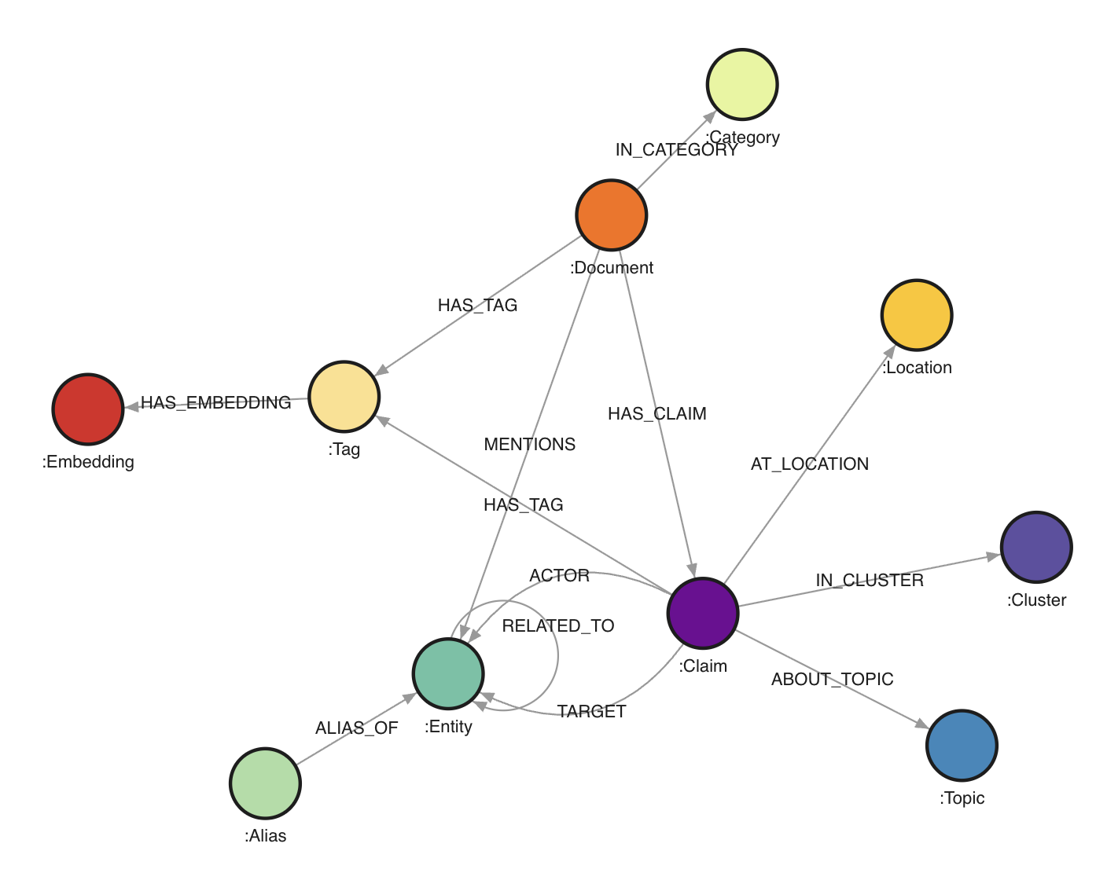
The graph contains 546,648 nodes and 1,432,277 edges.
Node labels:
- Document (25,233): one source document from the House Oversight dump. Important properties include doc_id, file_path, category, summaries, date range, and the full extracted text. The full text is not necessasy for the core assignment.
- Claim (106,012): one extracted statement or assertion. A claim roughly corresponds to one subject-predicate-object style extraction, with properties such as claim_id, action, timestamp, sequence_order, triple_tags, explicit_topic, implicit_topic, and top_cluster_ids.
- Entity (55,922): canonical real-world entities such as people, organizations, places, companies, aircraft, properties, and sometimes unresolved named things.
- Alias (28,934): alternative names mapped onto canonical entities.
- Tag (109,593): semantic tags attached either to documents or claims.
- Topic (184,695): explicit or implicit topics inferred for claims.
- Category (34): document categories such as email, report, book_excerpt, court_filing, and photo_caption.
- Location (6,506): raw location strings linked to claims.
- Cluster (30): coarse topical clusters assigned to claims.
- Embedding (29,689): embeddings linked to tags. These are mostly useful if you want to explore similarity-based extensions, but not necessary for the core assignment.
Edge types:
- (:Document)-[:IN_CATEGORY]-﹥(:Category): assigns a document to a category.
- (:Document)-[:HAS_TAG]-﹥(:Tag): content tags for a document.
- (:Document)-[:HAS_CLAIM]-﹥(:Claim): provenance link from a document to extracted claims.
- (:Document)-[:MENTIONS]-﹥(:Entity): entity mention relation at document level.
- (:Alias)-[:ALIAS_OF]-﹥(:Entity): alias resolution.
- (:Claim)-[:ACTOR]-﹥(:Entity): subject/actor side of the extracted relation.
- (:Claim)-[:TARGET]-﹥(:Entity): object/target side of the extracted relation.
- (:Claim)-[:AT_LOCATION]-﹥(:Location): location attached to a claim.
- (:Claim)-[:HAS_TAG]-﹥(:Tag): semantic tags attached to a claim.
- (:Claim)-[:ABOUT_TOPIC {kind: "explicit"|"implicit"}]-﹥(:Topic): topics attached to a claim.
- (:Claim)-[:IN_CLUSTER]-﹥(:Cluster): cluster membership for a claim.
- (:Entity)-[:RELATED_TO]-﹥(:Entity): derived traversal edge between actor and target. This edge contains properties such as action, doc_id, claim_id, timestamp, and sequence_order.
The practical consequence is that you can work at two levels:
- the document/evidence level via Document and Claim
- the network level via Entity and RELATED_TO
Objective
Your task for this assignment is to use Cypher queries and Gephi (or other visualization libraries) to analyze this data set.
You are free to explore anything you deem interesting and present your findings in your report.
The main goal is to get familiar with Cypher but also to hone your "storytelling" skills. Hence, try to focus on a single or a few hypotheses or findings you explore in full (with nicely formatted visualizations) and explaining what it says instead of just going for quick filter saying: "here are the three nodes with the most connections" (boring) or showing a graph hairball.
Below are some suggestions/tips of what you can go for:
- Perform community mining on (a subset of) the graph and see whether you can identify particular groups
- Explore the connections between known actors in Epstein's network
- Compare document categories: do court_filing documents produce a different network structure than photo_caption or email documents?
- Look at recent news stories and see if you can back them or expand on these based on the data set
- Compare “social” relations (attended, met, traveled with) with “legal” relations (testified, accused, investigated, represented) and see whether the same actors bridge both worlds
- Explore centrality, brokerage, or bridge nodes rather than only raw degree
- Focus on a single substory, for example aviation, Palm Beach, Mar-a-Lago, financial disclosures, or recruitment pathways
I.e. pick something you want to explore and try to work this out in full. You will note that the data set is likely too large to look at everything at once, so a guided “deep dive” will work better. Once you know what you want to focus on, you can also clean up the graph by e.g. removing nodes or edges you are not interested in, or exporting a subgraph (see below).
Setting up Memgraph and Gephi
We used to work with Neo4j for this assignment, which is a solid tool supporting lots of (data science) extensions, but has become so commercial lately that it is a hassle to download. It can also be quite slow. Instead, we’ll be working with Memgraph, which is also “open source but commercial”, but with the advantage that it is faster and easier to set up than Neo4j. It is mostly compatible (e.g. Cypher works the same), but some aspects (such as exporting data) are a bit trickier.
Memgraph provides an installer script which sets up a bunch of Docker containers using Docker Compose. Since this is becoming an increasingly common pattern, we can take this opportunity to get (a little bit) familiarized with Docker.
First, download and install Docker Desktop for your platform. Pick the free plan and log in with your Google or GitHub account. (Note: also Docker is obviously becoming more and more commercial. There are alternatives available such as Podman and Rancher, but these are a bit harder to set up correctly. Feel free to experiment with these if you want to but you are "on your own" in that case.)
Start Docker Desktop once it is installed. If running, you will see an icon in your task bar. Windows users: head to the settings window of Docker Desktop and select the WSL2 backend as the “engine” if possible. It is also a good idea to look under the "Resources" tab and increase the RAM (memory) docker containers can utilize, if you have the memory to spare.
You should be able to run the docker command on a command line / Terminal window:
docker
Usage: docker [OPTIONS] COMMAND
A self-sufficient runtime for containers
Commands: [A long list of commands]
Next, we will NOT use the provided installation script of Memgraph itself but instead use this docker-compose.yml file. Download this file and place it in an empty directory of your choosing. You can take a look at this file in a text editor to inspect the configuration it provides. It downloads two images, sets up two containers, exposes the necessary ports, attaches a volume, and sets a MEMGRAPH environment variable to increase the query time limit. If necessary, you can increase this limit.
In your command line window, navigate (cd) to the location where you've placed this file, and run the following command:
docker compose up
This will take a while the first time. Eventually, you should see the following message:
memgraph-lab | [20XX-XX-XX XX:XX:XX] INFO: Lab vX.X.X is running at http://localhost:3000 in production mode
Keep this window open to keep Memgraph running. In a web browser, navigate to: http://localhost:3000/. The Memgraph lab page should appear and should allow to connect to your locally running Memgraph instance. You can press CTRL+C in the command line window and run docker compose up again later to start Memgraph up again, or use the Docker Desktop app to start the two containers from there.
You won’t have any nodes or edges (yet). Download the data.cypherl data file. Since this file is large, importing it through the web interface will most likely make it crash, so we will use the mgconsole program instead. Open a new command line window (whilst Memgraph is still running) and navigate to the directory you downloaded the data.cypherl file to.
Then run:
cat data.cypherl | docker run -i --rm memgraph/mgconsole:latest --host host.docker.internal --port 7687
On Windows, use type instead of cat.
If you are using PowerShell on Windows, the equivalent is:
Get-Content .\data.cypherl | docker run -i --rm memgraph/mgconsole:latest --host host.docker.internal --port 7687
This should start importing the data. You can verify this by looking at the Memgraph Lab tab in your web browser and seeing the number of nodes and edges increase.
The total number of nodes and edges should reach 546,648 and 1,432,277 respectively. This might take some time to finish, but afterwards your data is ready in Memgraph.
In case of issues, you can always remove all containers, images and volumes using the Docker Desktop application and run docker compose up again. Or you can empty the database using this query:
MATCH (n) DETACH DELETE n;
Next, download and install Gephi for your OS.
Working with the Graph
You can execute queries in the “Query Execution” pane.
Feel free to play around with some Cypher queries to explore this graph, e.g.:
MATCH (e:Entity)-[r:RELATED_TO]-&gt;(f:Entity)
RETURN e, r, f
LIMIT 25;
- It’s a good idea to use limit in order not to overflow yourself with results
- Also note that we labeled the edge (r) here, otherwise, it will not be shown in the result (this is different from the default behavior from Neo4j which connects nodes)
- You can click nodes in the result view to see more info and expand them
Some more examples:
MATCH (d:Document)-[:IN_CATEGORY]-&gt;(c:Category)
RETURN c.name, count(d) AS n
ORDER BY n DESC;

MATCH (e:Entity {name: "Jeffrey Epstein"})-[r:RELATED_TO]-&gt;(other:Entity)
RETURN other.name, r.action, r.doc_id
LIMIT 50;

MATCH (d:Document)-[:HAS_CLAIM]-&gt;(c:Claim)-[:AT_LOCATION]-&gt;(l:Location)
WHERE l.name CONTAINS "Palm Beach"
RETURN d.doc_id, c.action, l.name
LIMIT 50;

MATCH (c:Claim)-[:ABOUT_TOPIC {kind: "explicit"}]-&gt;(t:Topic)
RETURN t.name, count(*) AS n
ORDER BY n DESC
LIMIT 25;

MATCH (a:Alias)-[:ALIAS_OF]-&gt;(e:Entity)
RETURN e.name, count(a) AS alias_count
ORDER BY alias_count DESC
LIMIT 25;

MATCH (d:Document)-[:HAS_CLAIM]-&gt;(c:Claim)-[:ACTOR]-&gt;(a:Entity)
MATCH (c)-[:TARGET]-&gt;(b:Entity)
RETURN d.doc_id, a.name, c.action, b.name
LIMIT 25;
Notice that the graph supports different styles of querying:
- Document and Claim for provenance and evidence
- Entity and RELATED_TO for social-network style analysis
- Tag, Topic, and Category for semantic filtering
You can change size and color of the node types as well as the attribute used to label them by going to the “Graph Style Editor” tab. Memgraph’s styling language is quite powerful. For more information, check out: https://memgraph.com/blog/how-to-style-your-graphs-in-memgraph-lab.
Using Gephi
To load the data in Gephi, we must get it out of Memgraph in some manner. There is a Neo4j Gephi plugin, but it has not received much attention lately and is incompatible with Memgraph.
Luckily, there is an export function to JSON from a query result from the web interface. To export query results from Memgraph Lab: run a query or select results you want to export. Click Export results and choose JSON.
This file can then be converted using the json2graphml.py Python script (note that you will need the networkx package):
uv run --with networkx json2graphml.py "memgraph-query-results-export.json"

Done, output file saved to: memgraph-query-results-export.graphml
(Note that this script attempts to perform a best-effort conversion and might not be 100% foolproof depending on the query you used.)
Feel free to use other Python (or JavaScript) libraries to make visualizations as well if you prefer these over Gephi. Memgraph itself has a good article with some tips over at https://memgraph.com/blog/graph-visualization-in-python.
Exporting CSV Files
To load data into Gephi, another workflow consists of creating:
- one CSV file with nodes
- one CSV file with edges
For example, you might first export the edges of a focused subgraph:
WITH "
MATCH (a:Entity)-[r:RELATED_TO]-&gt;(b:Entity)
WHERE a.name CONTAINS 'Epstein' OR b.name CONTAINS 'Epstein'
RETURN a.name AS source, b.name AS target, r.action AS action, r.doc_id AS doc_id
LIMIT 1000
" AS query
CALL export_util.csv_query(query, "/var/lib/memgraph/edges.csv", True)
YIELD file_path
RETURN file_path;
Then export the corresponding nodes:
WITH "
MATCH (e:Entity)
WHERE e.name CONTAINS 'Epstein'
RETURN e.name AS id, e.name AS label, e.entity_type AS entity_type
LIMIT 500
" AS query
CALL export_util.csv_query(query, "/var/lib/memgraph/nodes.csv", True)
YIELD file_path
RETURN file_path;
After copying the files out of the container (see below), you can import them into Gephi via the Data Laboratory:
- import nodes.csv as a nodes table
- import edges.csv as an edges table
- make sure the source/target columns refer to the node ids you exported
It is recommended to run these commands in a terminal window rather than from the web interface. How do you get a terminal query prompt to Memgraph? By executing the following command in a separate Terminal window:
On Linux:
docker run -it --rm --network host memgraph/mgconsole:latest
On macOS or Windows:
docker run -it --rm memgraph/mgconsole:latest --host host.docker.internal --port 7687
(Note the -it instead of just -i earlier). A prompt will open on which you can execute queries:
memgraph: WITH "[YOUR QUERY HERE]" AS query
CALL export_util.csv_query(query, "/var/lib/memgraph/my_export.csv", True)
YIELD file_path
RETURN file_path;
+-------------------------------------------------+
| file_path |
+-------------------------------------------------+
| "/var/lib/memgraph/my_export.csv" |
+-------------------------------------------------+
1 row in set (round trip in 0.118 sec)
We use /var/lib/memgraph/ as the path to export to. Note that this location is inside of the docker container. So how to get it out? We can copy the file as follows:
docker cp bd6b5372d713:/var/lib/memgraph/my_export.csv my_export.csv

Successfully copied 24.6kB to G:\my_export.csv
You will have to replace the identifier bd6b5372d713 with the one on your machine. You can get this identifier by running docker ps and getting the id for memgraph/memgraph-mage:latest. The file is then present on your local environment. In practice, exporting focused node and edge CSV files is usually the easiest route into Gephi.
In practice, for this assignment, the best approach is usually:
- formulate a small, targeted Cypher query
- export only the resulting subgraph
- visualize and refine
That approach is much better than dumping the entire graph into Gephi and ending up with an unreadable hairball.
You do not hand in each assignment separately, but hand in your completed lab report containing all four assignments on Sunday May 31st. For an overview of the groups, see Toledo. Note for externals (i.e. anyone who will NOT partake in the exams -- this doesn't apply to normal students): you are free to partake in (any of) the assignments individually, but not required to.
×

